Product Documentation: Book Nook Web Application

**Introduction**

The **BookNook** web application is a platform designed for book enthusiasts to explore, review, and manage a collection of books. It offers functionalities for users to browse available books, read and write reviews, and manage their profiles. Administrators have additional capabilities to add new books, edit existing entries, and oversee user reviews.

**Website Functionality**

**User Features:**

* **User Registration and Authentication:** Users can create an account and log in to access personalized features.
* **Book Browsing:** Explore a catalog of books with details such as title, author, genre, and description.
* **Book Details and Reviews:** View detailed information about each book, including user-submitted reviews and ratings.
* **Review Management:** Authenticated users can submit reviews for books and edit or delete their own reviews.
* **Profile Management:** Users can view and edit their personal profiles, including updating information and changing passwords.

**Administrative Features:**

* **Administrative Functions:** Administrators can add new books, edit existing book details, and manage user reviews to ensure content quality.

**Page Descriptions**

1. **Home Page (index.php):**
   * 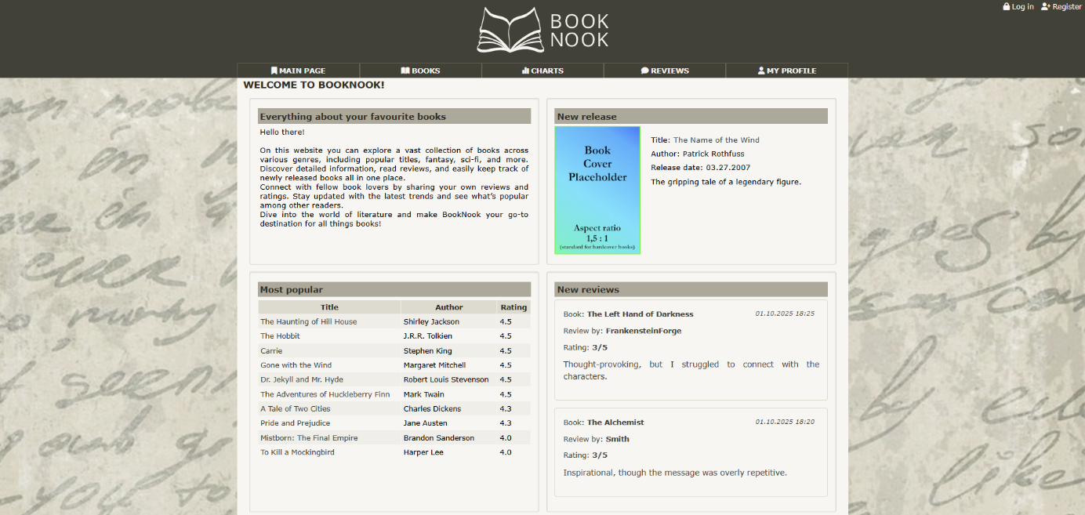The landing page that provides an overview of the website and highlights featured books or recent reviews.
2. **Books Listing (books.php):**
   * Displays a paginated list of all books in the catalog, with options to sort and filter by various criteria.

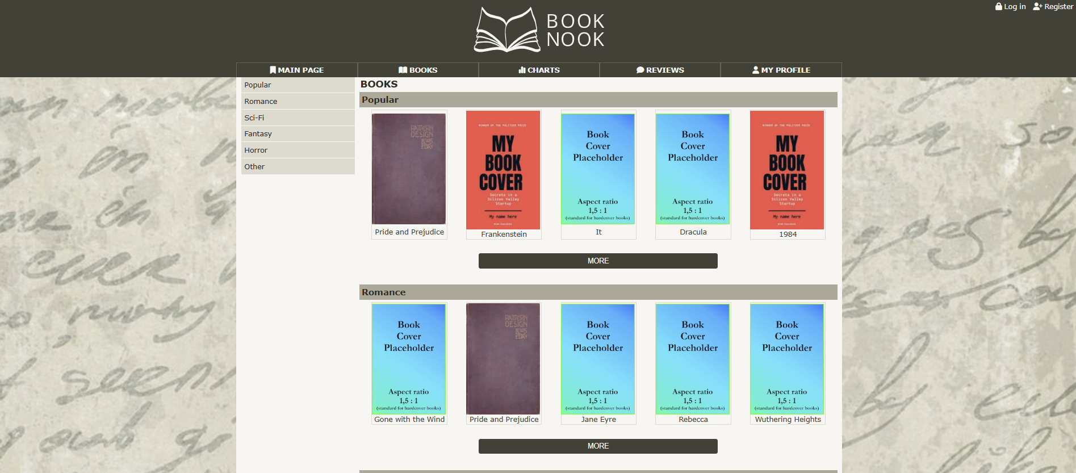

1. **Book Details (book_detail.php):**
   * Shows comprehensive information about a selected book, including its description, author, and user reviews.

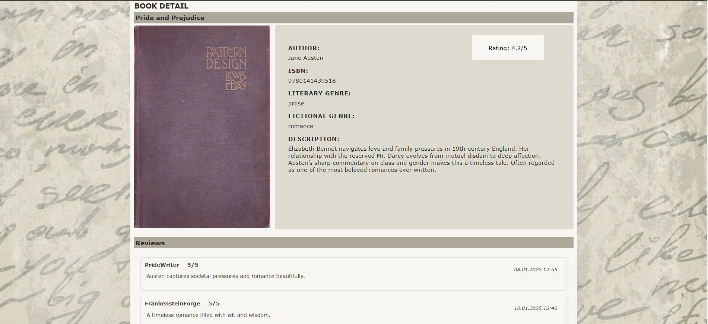

1. **Add New Book (book_add.php):**
   * Accessible to administrators, this page provides a form to input details for adding a new book to the catalog.

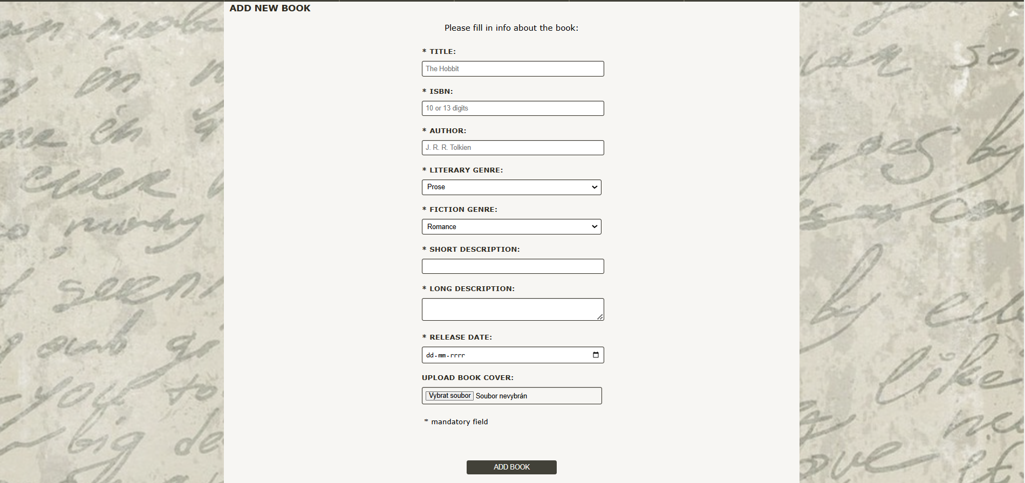

1. **Edit Book (book_edit.php):**
   * Allows administrators to modify details of an existing book entry.
2. **User Registration (register.php):**
   * Enables new users to create an account by providing necessary personal information.

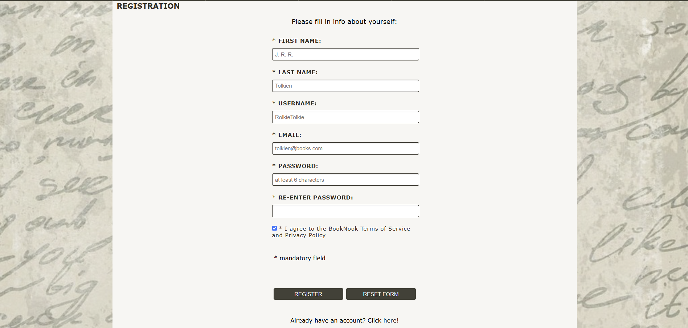

1. **User Login (login.php):**
   * Allows existing users to log in to their accounts using their credentials.



1. **User Profile (profile.php):**
   * Displays the user's profile information and provides options to edit details or change the password.
2. **Edit Profile (profile-edit.php):**
   * Enables users to update their personal information and account settings.
3. **Admin Dashboard (admin.php):**
   * Accessible only to administrators, this page offers an overview of administrative functions, including managing books, users and reviews.

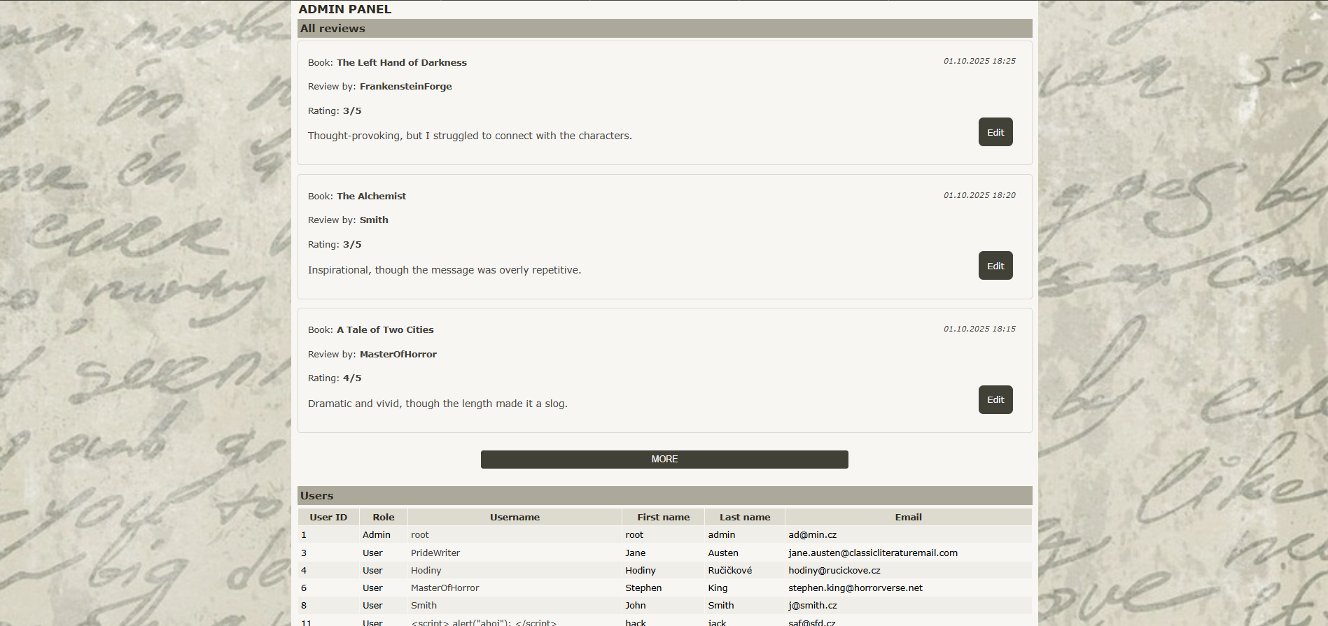

1. **Reviews Management (reviews.php):**
   * Allows to view all user reviews chronologically.

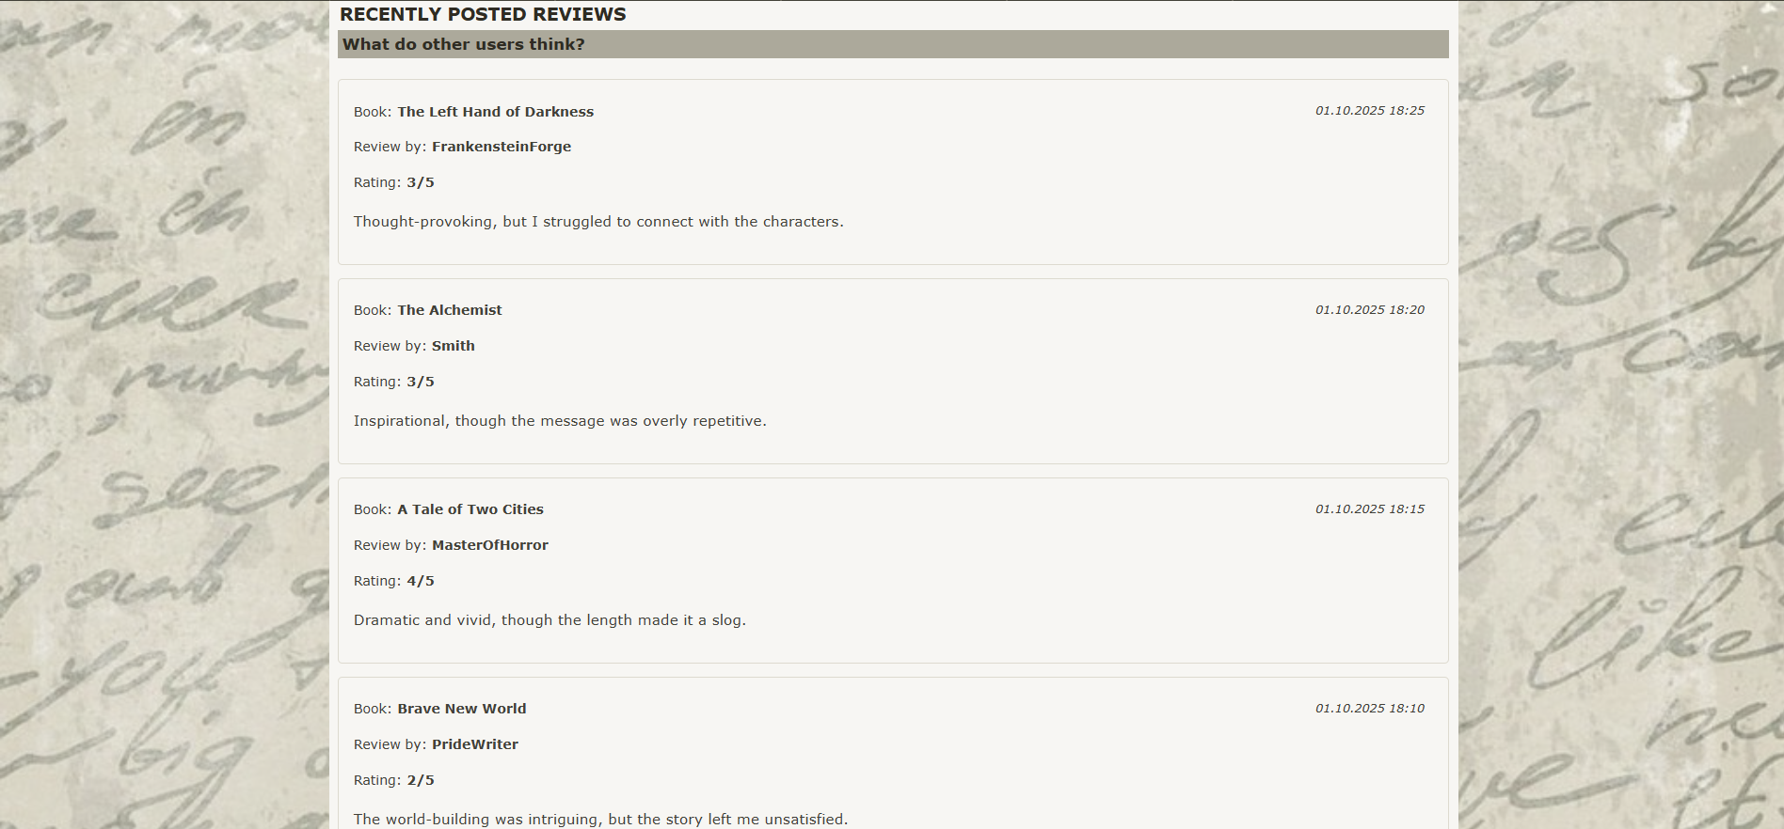

1. **Edit Review (review_edit.php):**
   * Provides users with the ability to edit their previously submitted reviews.
2. **Charts and Statistics (charts.php):**
   * Displays graphical representations of data, such as the best rated books in each category.

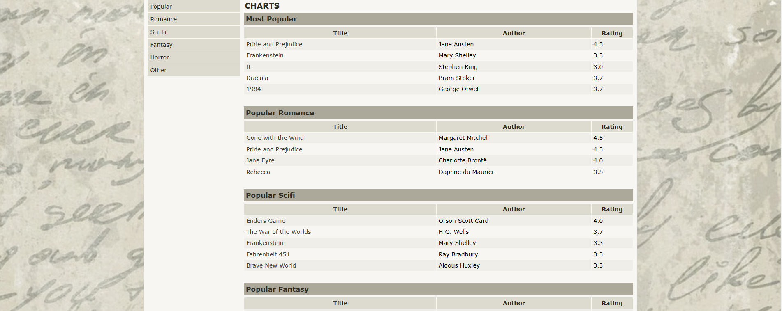

1. **Logout (logout.php):**
   * Logs the user out of their account and redirects them to the home page.

**Design Principles**

* **Responsive Design:** The application is designed to provide optimal viewing across various devices, including desktops, tablets, and smartphones.
* **User-Friendly Interface:** Each page is designed with intuitive navigation and accessibility in mind.
* **Secure Authentication:** User accounts and sensitive information are protected using secure authentication methods.